Carlos Lopez

Professor Sweeting

KHC HC301

November 15, 2020

**Literature Review**

**Abstract:**

Research data shows that the United States is one of the main contributors to the growing climate change crisis due to its over-emission of greenhouse gases into the atmosphere (EPA, 2020). Moreover, it ranks second only to China in the list of the top 20 countries with the most carbon dioxide emissions despite having a population more than 4 times smaller than China’s (Union of Concerned Scientists, 2020). Hence, it is imperative that we reduce this number drastically through the coming years through implementing certain changes to the way the United States produces and utilizes energy. Such changes include switching from coal to other renewable energy sources, changing our methods of transportation, and by implementing new, more green guidelines and regulations to our government.

**Introduction:**

Even though coal has only been used as an energy source for a little more than 200 years when the first industrial revolution started, it has quickly become the primary energy source of the United States. As a result, we now emit an unsustainable amount of carbon into the atmosphere every year. This contributes to the ubiquitous global warming of the Earth that we are all experiencing and the overall detrimental effects of climate change. In an effort to reduce these carbon emissions, several alternatives and plans have been proposed such as replacing coal with better and more renewable energy sources and advocating for the New Green Deal to be implemented into our government, but to understand their possible impact to our country, we first need to understand the United States’s current situation.

1. **The U.S.’s use of coal over the years**

First, let us truly grasp the magnitude with which the we pump greenhouse gases into the atmosphere. Here’s the breakup of greenhouse gases expelled into the atmosphere by the United States over the last few decades as described by the environmental protection agency (EPA, 2020):

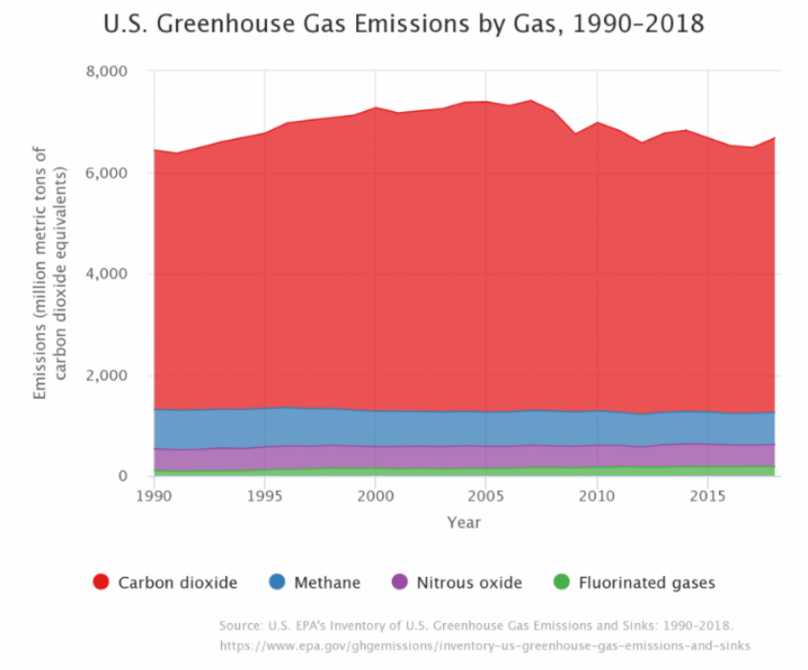

As you can see, in 2018 alone 6,677 million metric tons of carbon dioxide were expelled into the atmosphere. This accounts for more than 80% of the greenhouse gas emissions by the United States into the atmosphere that year. Hence, it appears as though, despite not being the only contributor to climate change, carbon dioxide is quite a major contributor to greenhouse gas emissions. Hence, we need to analyze where all these gases are coming from. Below, we can see the distribution with which several of the United States’ industries contribute to its total greenhouse gas emissions:

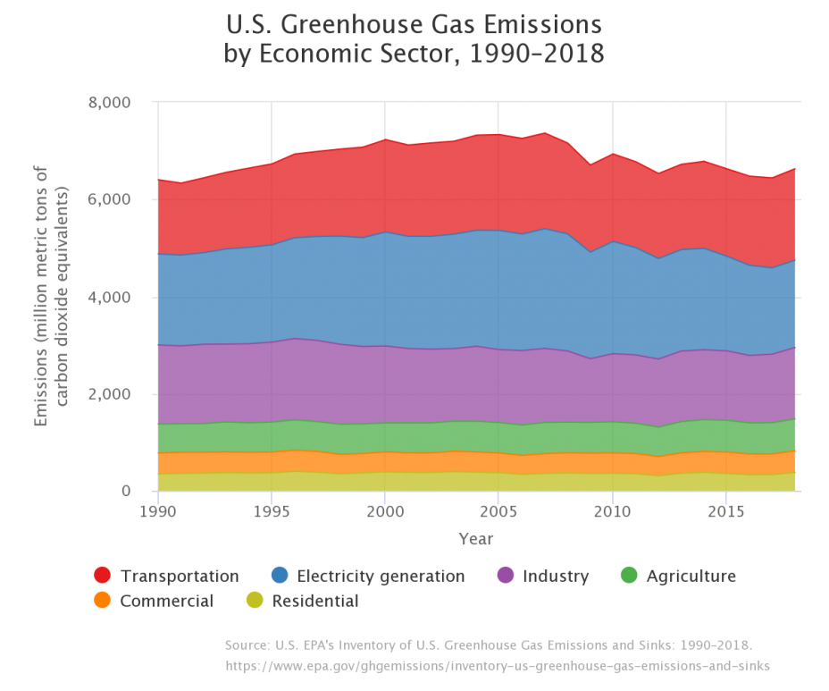

Therefore, we can identify electricity generation and transportation as the main contributors to the United States’ greenhouse emissions.

1. **The effects this has on the environment**

The theory of the greenhouse effect was actually first suggested back in 1824 by Joseph Fourier, a French Mathematician and Physicist, when his calculations told him that considering the size of the Earth and its distance from the Sun, the Earth should be a lot colder than the temperatures we’re familiar with. Hence, he theorized that the Earth’s atmosphere must indeed be responsible for the extra heat and must act as some sort of insulator. Since then, this theory has been formalized and proven by scientists such as John Tyndall who further developed the theory and Svante Arrhenius who linked it with fossil fuel combustion and increased carbon dioxide (Weart, 2020).

However, it was not until recently that we started taking note of the effects. As of January 2020, the planet’s average surface temperature has risen about 2.05 degrees Fahrenheit when compared to the tail end of the 19th century with most of it having happened in the past 40 years. In addition, 2016 became the warmest year on record with eight months out of the year being the warmest ever recorded (Schmidt, 2020). This increased warming has in turn warmed the ocean whose top 100 meters are now hotter by about 0.6 degrees Fahrenheit when compared to 1969. In addition, several glaciers from around the world have been melting rapidly and are losing thickness, the Arctic Sea ice has been melting, and the amount of spring snow cover in the Northern Hemisphere has drastically decreased over the past few decades (Shaftel, 2020).

However, all this increased warming is only the most direct effect of the greenhouse effect. The truly devastating effects come from what results of all this warming. Besides record high temperatures, more droughts and heat waves are being experienced which have led to many forest fires in the last couple of years (Shirah, 2015). Intense rainfall has become more common and the average U.S. precipitation has increased since the 1900s which has resulted in hurricanes having become more intense and more frequent (Goddard, 2016). The sea level is expected to rise up to 8 feet in the coming years, swallowing a lot of land and increasing the amount of floods people will experience (Shaftel, 2020). The list just goes on. Even worse, is that humans are not the only ones affected. To name a few victims, animals are being displaced from their habitat, plant patterns are becoming more irregular, people are losing their homes to natural disasters, and ocean acidification is killing a lot of sea life. Therefore, the next question to ask is “How do we stop this?”

1. **Alternatives and Solutions**

Sadly, the main and only real way that we currently have of removing greenhouse gases from the atmosphere is to let it be absorbed by plants as part of their biological carbon cycle (Cho, 2020). Therefore, for the moment being, the best we can do is limit our contribution to greenhouse gases in the atmosphere and urge other countries to do the same. There are many proposed methods as to how to accomplish this, but the main ones are:

1. **Switching from Coal to Nuclear Energy**

Nuclear power plants are among the renewable energy sources that produce the least greenhouse gases along with solar and wind energies. However, the main problem with solar and wind is that they do not produce energy constantly and reliably. If the day is cloudy or if there is not much wind in a particular day, then energy cannot be produced from these sources and a backup energy source, most often the burning of gas or coal, must be used that day to keep providing electricity to the industries and families that need it (Frankfurt, 2019). This of course ends up producing a considerably greater amount of greenhouse gases in the long run when compared to nuclear energy which can run year-round. This is reflected very well in the daily carbon emissions of France and Germany:

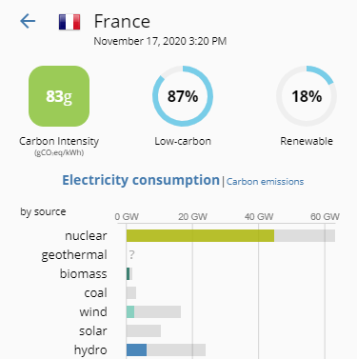 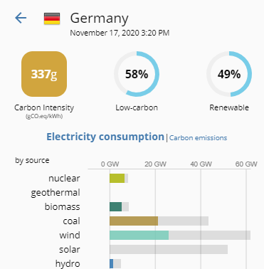 [Source: <https://www.electricitymap.org/>]

As you can see, both countries have been moving towards using more renewable energy sources (the grey bars represent the maximum installed capacity for these resources). However, France is mainly focusing on transitioning towards nuclear energy while Germany has been transitioning towards wind and solar energy. Now if we look specifically at Germany, we can see that its energy sources still have somewhat of a co-dependance with coal. Its current high use of coal seems to be linked with the fact that its solar power is going completely unused due to it being nighttime at the time the data was acquired. It is all these factors combined that amount to the live carbon emissions of France to in general be about four times less than that of Germany (Tomorrow, 2020).

However, despite all the benefits of nuclear energy, the fear of its dangers has held back its development and widespread use. As of 2018, nuclear energy only constitutes about 5% of global primary energy production (Buongiorno et. al, 2018). If looked at from the perspective of a business entrepreneur, building a powerplant represents a way bigger risk than other sorts of plants like a gas or coal plant for example. Nuclear plants take quite a lot longer to construct (about 5-7 years vs. a gas plant only taking about 2) and since no returns on investment can be made until the plant is functioning, the entrepreneur will go into a lot of debt during the plant’s construction period. In addition, the public’s view on nuclear energy has never been that good due to it quite easily being associated with nuclear bombs or disasters like Chernobyl. In addition, the visible fumes that emanate from the nuclear reactors are often perceived by individuals as harmful fumes being leaked into the environment despite them only being steam (Energy, 2013). Therefore, protests and work strikes often happen and they may delay or even impede the plant’s construction altogether. However, if construction is finished, nuclear energy is among the most profitable energy power plants since it’s fuel source, uranium or (only quite recently) thorium, yields a lot more energy per kilogram than even coal which means that a lot less fuel and, by extension, money is needed to maintain it running (Ruzic, 2019).

1. **Transportation Alternatives**

Not only is transportation a main carbon dioxide contributor in the United States, but in fact it is responsible for about 23% of the globe’s greenhouse gas emissions every year. Out of that percentage, transportation in roads produces 75% of gas emissions (Rinkesh, 2017). In addition, the building of roads themselves emit quite a lot of carbon dioxide. According to the Chatham House, the production of cement is responsible for about 8% of the world’s carbon dioxide emissions. To put this into perspective, if cement were a country, it would be the third largest carbon emitter in the world, closely behind China and the United States (Rodgers, 2018). Therefore, it seems appropriate that we should try to limit our use of fossil fuel vehicles until we can find a substitute transportation method. Up until very recently, the main alternative that was being suggested was to bike instead of drive. However, that is not a realistic possibility for many people, especially those with bigger families or those that commute long distances to get to work. However, as technology advances rapidly, a new transportation method is being integrated into society, the electric car.

Although electric cars have been around since the 1800’s, there was not much interest in them due to certain limitations in their technology. Namely, up to the 1970’s, they could not go faster than 45 mph and could only be driven for about 40 miles before needing to be recharged again. (Matulka, 2014). It was not until the late 90’s that a renewed interest in them began to appear. This was mainly due to the passage of the 1990 Clean Air Act Amendment and the 1992 Energy Policy Act along with other transportation regulations that limited the allowed carbon emissions in cars at the time (Matulka, 2014). People modifying their cars to turn them into electric or hybrid vehicles became more common, and even some companies got part of the action such as General Motors with their EV1 which to this day is considered the first mass-produced and purpose-designed electric vehicle of the modern era from a major automaker (Adler, 2018). This spark of interest has only been further developed by companies such as Tesla constantly improving the concept of the electric car. Tesla started in 2006 with the help of a $465 million loan from the Department of Energy’s Loan Programs Office, but this loan was quickly repaid 9 years early (Matulka, 2014). Since then, this company has made it more possible than ever for the average consumer to get his hands in an electric car. Despite this, electric cars are still somewhat chastised as people believe that the mining of the car’s core battery metal, lithium, along with the fact that the energy needed to charge the cars still predominantly comes from coal power plants produces just as many carbon emissions as a regular car. However, this is not the case since rather than having a million small greenhouse gas emitters, one for every car, all this emission is taken care of at the main power plant such that it is easier to manage and less overall emissions are produced (Matulka, 2014). In addition, as the technology of the lithium battery improves, their lifespan and rechargeability become longer and better so that less mining is done over time. Currently, Tesla is aiming to achieve 3 terawatt-hours of battery capacity in its vehicles by 2030 which is more than fifty times what today’s supply can yield (Root, 2020). However, to achieve these goals, the company needs to remain profitable, but to the surprise of many and despite having a bit of a bumpy start, as of this January of this year Tesla was valued by investors at over $90 billion dollars, much higher than that of General Motors at about $50 billion and Ford at about $37 billion (Randewich, 2020). However, that number has only kept skyrocketing since then to the point where Tesla is now valued at $450 billion (as of September) and has become the world’s most valuable car maker in the world with Toyota in second place at about $216 billion (Beresford, 2020). All of this reflects the general public’s desire and expectations for green companies like Tesla who try to seize the future.

1. **The Green New Deal**

When talking about becoming green for the future, there seems to be no clearer pathway there than that of the “Green New Deal.” Contrary to popular belief, the green new deal is not a bill waiting to be turned into a law but rather a proposal or set of guidelines for the government to follow to reduce carbon emissions as much as possible and to lead other countries to do the same. It is pretty short and is available for anyone to read right here: <https://www.congress.gov/116/bills/hres109/BILLS-116hres109ih.pdf> Despite not enforcing much legal power, what this paper accomplishes is to set a very specific set of goals that the United States should achieve before 2050. This would in turn push the United States government towards “greener” alternatives. Oddly enough, despite how often the “Green New Deal” is mentioned, few Americans actually know what it talks about. According to a 2019 poll by the Washington Post and the Kaiser Family Foundation, 3 in 4 Americans felt they did not know enough about it to form an opinion on it (Grandoni, 2019). Therefore, allow me to summarize the paper by stating the seven main discussed goals to be achieved which are

* Shift 100% of national power generation to renewable sources.
* Build a national energy-efficient "smart" grid.
* Upgrade all buildings to become energy efficient.
* Decarbonize manufacturing and agricultural industries.
* Decarbonize, repair, and upgrade the nation's infrastructure, especially transportation.
* Fund massive investment in the drawdown and capture of greenhouse gases.
* Adopting these goals would make "green" technology, industry, expertise, products, and services a major U.S. export. As a result, America could become an international leader in helping other countries transition to completely carbon-neutral economies (Cortez, 2019).

This deal has also met a decent amount of opposition by certain sections of the public. It is most often compared to Obama’s $90 billion climate package that he deployed back in 2009 as part of the $800 billion American Recovery and Reinvestment Act of 2009 or “the stimulus” as many people called it, and it is also believed that it will not change much of the present situation, much like that climate package did not (Grunwald, 2019). In addition, other individuals argue that this document does not in fact address the conflict between the greedy growth and consumption associated with capitalism and the need for us to limit our use of the environment, but rather this document merely represents the “green dream” of an individual (Dyne, 2019). Regardless of this, the document seems to be getting quite a lot of momentum. Over 100 Congress members have endorsed the Green New Deal resolution and several polls still show broad support for this plan. Even some cities and states have already started laying down the groundwork for this resolution such as New York City whom recently passed the Climate Mobilization Act which will require about 50,000 large buildings to follow certain regulations to greatly reduce their carbon pollution (Sierra Club, 2019).

1. **Conclusion**

We should all put in the effort to reduce global warming as much as possible to avoid further catastrophe in our ecosystem and the lives of those around us. Allowing our country to wastefully emit the quantity of greenhouse gases that it does into the atmosphere is inexcusable, and as such we need to change the way our country functions. Seeking out cleaner forms of energy, changing the way we transport ourselves, showing our government that we want to and need to change for the better are all things that we should be doing for the sake of our country, planet, and brethren, before we lose them altogether.

**Bibliography**

Adler, A. L. (2018, August 31). ELECTRIFYING ANSWERS. Retrieved November 15, 2020, from https://www.chicagotribune.com/news/ct-xpm-1996-09-29-9609280010-story.html

Beresford, C. (2020, November 10). Elon Musk's Net Worth Has Skyrocketed over $100 Billion. Retrieved November 15, 2020, from https://www.caranddriver.com/news/a33860968/elon-musk-net-worth-100-billion/

Buongiorno, J., Parsons, J., Corradini, M., Petti, D., & Et. al, .. (2018). *The Future of Nuclear Energy in a Carbon-Constrained World* (Publication). Retrieved November 15, 2020, from MIT Energy Initiative website: https://energy.mit.edu/wp-content/uploads/2018/09/The-Future-of-Nuclear-Energy-in-a-Carbon-Constrained-World.pdf

Cho, R. (2019, September 26). Can Removing Carbon From the Atmosphere Save Us From Climate Catastrophe? Retrieved November 15, 2020, from https://blogs.ei.columbia.edu/2018/11/27/carbon-dioxide-removal-climate-change/

Cortez, O. (2019, February 7). H. RES. 109: Recognizing the duty of the Federal Government to create a Green New Deal. Retrieved November 15, 2020, from https://www.congress.gov/116/bills/hres109/BILLS-116hres109ih.pdf

DSouza, D. (2020, October 08). The Green New Deal Explained. Retrieved November 15, 2020, from https://www.investopedia.com/the-green-new-deal-explained-4588463

Dyne, B., & Grey, B. (2019, March 5). The fallacies and evasions of the Green New Deal. Retrieved November 15, 2020, from https://www.wsws.org/en/articles/2019/03/05/deal-m05.html

E.P.A. (2020, September 08). Overview of Greenhouse Gases. Retrieved November 15, 2020, from <https://www.epa.gov/ghgemissions/overview-greenhouse-gases>

E.P.A. (2020, September 11). Inventory of U.S. Greenhouse Gas Emissions and Sinks. Retrieved November 15, 2020, from https://www.epa.gov/ghgemissions/inventory-us-greenhouse-gas-emissions-and-sinks

Energy, D. (2013, June 12). Common Myths About Nuclear Energy. Retrieved November 15, 2020, from https://nuclear.duke-energy.com/2013/06/12/common-myths-about-nuclear-energy

Frankfurt School – UNEP Collaborating Centre for Climate & Sustainable Energy Finance. (2019). GLOBAL TRENDS IN RENEWABLE ENERGY INVESTMENT 2019. Retrieved November 15, 2020, from https://wedocs.unep.org/bitstream/handle/20.500.11822/29752/GTR2019.pdf

Friedman, L. (2019, February 21). What Is the Green New Deal? A Climate Proposal, Explained. Retrieved November 15, 2020, from https://www.nytimes.com/2019/02/21/climate/green-new-deal-questions-answers.html

Grandoni, D., & Clement, S. (2019, November 27). Americans like Green New Deal’s goals, but they reject paying trillions to reach them. *Washington Post*. Retrieved November 15, 2020, from https://www.washingtonpost.com/climate-environment/2019/11/27/americans-like-green-new-deals-goals-they-reject-paying-trillions-reach-them/

Grunwald, M., White, J., Sitrin, S., & Gerstein, B. (2019, January 15). The Trouble With the 'Green New Deal'. Retrieved November 15, 2020, from https://www.politico.com/magazine/story/2019/01/15/the-trouble-with-the-green-new-deal-223977

Matulka, R. (2014, September 15). The History of the Electric Car. Retrieved November 15, 2020, from https://www.energy.gov/articles/history-electric-car

NASA's Goddard Space Flight Center. (2016, May 27). GMS: Ten-Year Gap in Major Hurricanes Continues. Retrieved November 15, 2020, from https://svs.gsfc.nasa.gov/12251

National Geographic Society. (2012, December 18). Coal. Retrieved November 15, 2020, from https://www.nationalgeographic.org/encyclopedia/coal/

Randewich, N. (2020, January 08). Tesla's market value zooms past that of GM and Ford - combined. Retrieved November 15, 2020, from https://www.reuters.com/article/us-usa-stocks-tesla/teslas-market-value-zooms-past-that-of-gm-and-ford-combined-idUSKBN1Z72MU

Rinkesh. (2017, January 15). Modes and Benefits of Green Transportation. Retrieved November 15, 2020, from https://www.conserve-energy-future.com/modes-and-benefits-of-green-transportation.php

Rodgers, L. (2018, December 17). Climate change: The massive CO2 emitter you may not know about. Retrieved November 15, 2020, from https://www.bbc.com/news/science-environment-46455844

Root, A. (2020, October 01). Why Lithium Could Be a New Risk for Tesla and Other Electric-Vehicle Makers. Retrieved November 15, 2020, from https://www.barrons.com/articles/new-risk-tesla-other-electric-vehicle-makers-lithium-supply-batteries-51601498472

Ruzic, D. (Director), & University of Illinois (Producer). (2019, May 14). *The Economics of Nuclear Energy* [Video file]. Retrieved November 15, 2020, from https://www.youtube.com/watch?v=cbeJIwF1pVY&ab_channel=IllinoisEnergyProf

Schmidt, G. A. (2020, November 12). Data.GISS: GISS Surface Temperature Analysis (GISTEMP v4). Retrieved November 15, 2020, from https://data.giss.nasa.gov/gistemp/

Shaftel, H. (2020, July 29). Sea Level. Retrieved November 15, 2020, from https://climate.nasa.gov/vital-signs/sea-level/

Shaftel, H. (Ed.). (2020, October 06). Climate Change Evidence: How Do We Know? Retrieved November 15, 2020, from https://climate.nasa.gov/evidence/

Shirah, G., & Zhang, C. (2015, February 12). SVS: Megadroughts in U.S. West Projected to be Worst of the Millennium. Retrieved November 15, 2020, from <https://svs.gsfc.nasa.gov/cgi-bin/details.cgi?aid=4270>

Sierra Club. (2019, December 04). A Green New Deal Is Already Underway in States and Cities. Retrieved November 15, 2020, from https://www.sierraclub.org/trade/green-new-deal-already-underway-states-and-cities

Tomorrow. (2020). Live CO₂ emissions of electricity consumption. Retrieved November 15, 2020, from https://www.electricitymap.org/

Union of Concerned Scientists. (2020, August 12). Each Country's Share of CO2 Emissions. Retrieved November 15, 2020, from <https://www.ucsusa.org/resources/each-countrys-share-co2-emissions>

Weart, S. (2020, January). The Discovery of Global Warming. Retrieved November 15, 2020, from https://history.aip.org/history/climate/co2.htm